To complete this assignment, you need to go through three parts:
- PART A: IP v4,
- PART B: NAT , and
- PART C: DHCP
Please read the specifications for each lab carefully before you begin.
Wireshark Lab:  IP v4  Supplement to Computer Networking: A Top-Down Approach, 9th ed., J.F. Kurose and K.W. Ross  “Tell me and I forget. Show me and I remember. Involve me and I understand.” Chinese proverb  © 2005-2025, J.F Kurose and K.W. Ross, All Rights Reserved | 

Specifications for PART A: IP v4.
- Use your own captured trace file to answer the questions in this IPv4 lab.
- It is recommended to use Linux or macOS for conducting this experiment.
In this lab, we’ll investigate the celebrated IP protocol, focusing on the IPv4 datagram. This lab has two parts. In the first part, we’ll analyze packets in a trace of IPv4 datagrams sent and received by the traceroute program (the traceroute program itself is explored in more detail in the Wireshark ICMP lab). We’ll study IP fragmentation in Part 2 of this lab.

Before getting started, you’ll probably want to review sections 1.4.3 in the text and section 3.4 of RFC 2151 to update yourself on the operation of the traceroute program. You’ll also want to read Section 4.3 in the text, and probably also have RFC 791 on hand as well, for a discussion of the IP protocol. If you answer the questions on IP fragmentation, you’ll definitely also want to review material on IP fragmentation. Although we’ve removed the topic of IP fragmentation from the 8th edition of our textbook (to make room for new material), you can find material on IP fragmentation from the 7th edition of our textbook (and earlier) at http://gaia.cs.umass.edu/kurose_ross/Kurose_Ross_7th_edition_section_4.3.2.pdf.

Capturing packets from an execution of traceroute

In order to generate a trace of IPv4 datagrams for the first two parts of this lab, we’ll use the traceroute program to send datagrams of two different sizes to gaia.cs.umass.edu. Recall that traceroute operates by first sending one or more datagrams with the time-to-live (TTL) field in the IP header set to 1; it then sends a series of one or more datagrams towards the same destination with a TTL value of 2; it then sends a series of datagrams towards the same destination with a TTL value of 3; and so on. Recall that a router must decrement the TTL in each received datagram by 1 (actually, RFC 791 says that the router must decrement the TTL by at least one). If the TTL reaches 0, the router returns an ICMP message (type 11 – TTL-exceeded) to the sending host. As a result of this behavior, a datagram with a TTL of 1 (sent by the host executing traceroute) will cause the router one hop away from the sender to send an ICMP TTL-exceeded message back to the sender; the datagram sent with a TTL of 2 will cause the router two hops away to send an ICMP message back to the sender; the datagram sent with a TTL of 3 will cause the router three hops away to send an ICMP message back to the sender; and so on. In this manner, the host executing traceroute can learn the IP addresses of the routers between itself and the destination by looking at the source IP addresses in the datagrams containing the ICMP TTL-exceeded messages.

Let’s run traceroute and have it send datagrams of two different sizes. The larger of the two datagram lengths will require traceroute messages to be fragmented across multiple IPv4 datagrams.

- Linux/MacOS. With the Linux/MacOS traceroute command, the size of the UDP datagram sent towards the final destination can be explicitly set by indicating the number of bytes in the datagram; this value is entered in the traceroute command line immediately after the name or address of the destination. For example, to send traceroute datagrams of 2000 bytes towards gaia.cs.umass.edu, the command would be:
%traceroute gaia.cs.umass.edu 2000
- Windows. The tracert program provided with Windows does not allow one to change the size of the ICMP message sent by tracert. So it won’t be possible to use a Windows machine to generate ICMP messages that are large enough to force IP fragmentation. However, you can use tracert to generate small, fixed length packets to perform Part 1 of this lab. At the DOS command prompt enter:
>tracert gaia.cs.umass.edu

Do the following:
- Start up Wireshark and begin packet capture. (Capture->Start or click on the blue shark fin button in the top left of the Wireshark window).
- Enter two traceroute commands, using gaia.cs.umass.edu as the destination, the first with a length of 56 bytes. Once that command has finished executing, enter a second traceroute command for the same destination, but with a length of 3000 bytes.
- Stop Wireshark tracing.

Part 1: Basic IPv4

In your trace, you should be able to see the series of UDP segments (in the case of MacOS/Linux) or ICMP Echo Request messages (Windows) sent by traceroute on your computer, and the ICMP TTL-exceeded messages returned to your computer by the intermediate routers. In the questions below, we’ll assume you’re using a MacOS/Linux computer; the corresponding questions for the case of a Windows machine should be clear. Your screen should look similar to the screenshot in Figure 2, where we have used the display filter “udp||icmp” (see the light-green-filled display-filter field in Figure 2) so that only UDP and/or ICMP protocol packets are displayed.

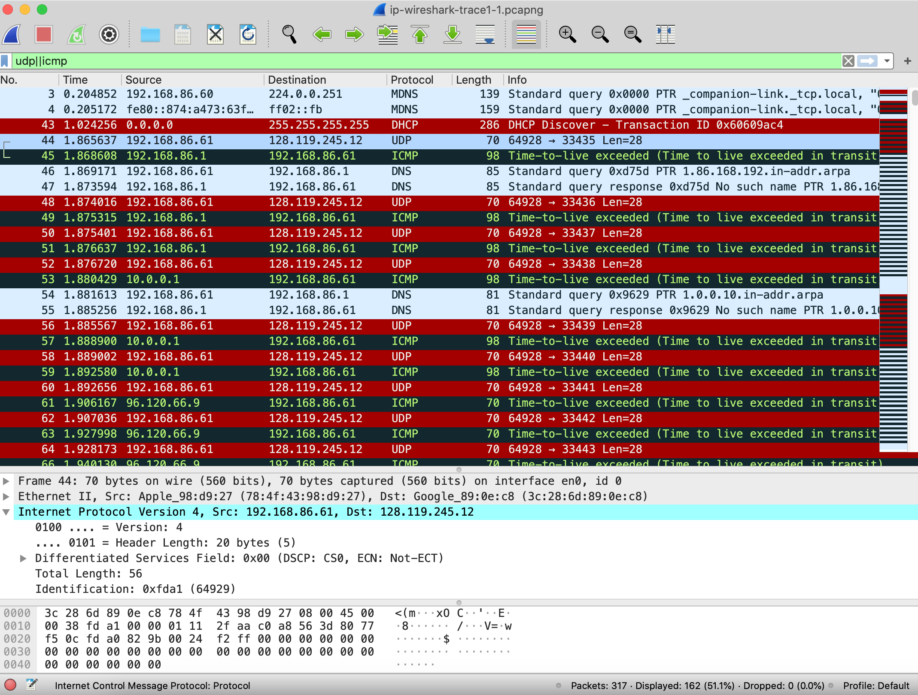
Figure 2: Wireshark screenshot, showing UDP and ICMP packets in the tracefile ip-wireshark-trace1-1.pcapng

Answer the following questions.

- Select the first UDP segment sent by your computer via the traceroute command to gaia.cs.umass.edu. (Hint: this is 44th packet in the trace file in the ip-wireshark-trace1-1.pcapng file in footnote 2). Expand the Internet Protocol part of the packet in the packet details window. What is the IP address of your computer?
- What is the value in the time-to-live (TTL) field in this IPv4 datagram’s header?
- What is the value in the upper layer protocol field in this IPv4 datagram’s header? [Note: the answers for Linux/MacOS differ from Windows here].
- How many bytes are in the IP header? How many bytes are in the payload of the IP datagram?
- Has this IP datagram been fragmented? Explain how you determined whether or not the datagram has been fragmented.

Next, let’s look at the sequence of UDP segments being sent from your computer via traceroute, destined to 128.119.245.12. The display filter that you can enter to do this is “ip.src==192.168.86.61 and ip.dst==128.119.245.12 and udp and !icmp”. This will allow you to easily move sequentially through just the datagrams containing just these segments. Your screen should look similar to Figure 3.

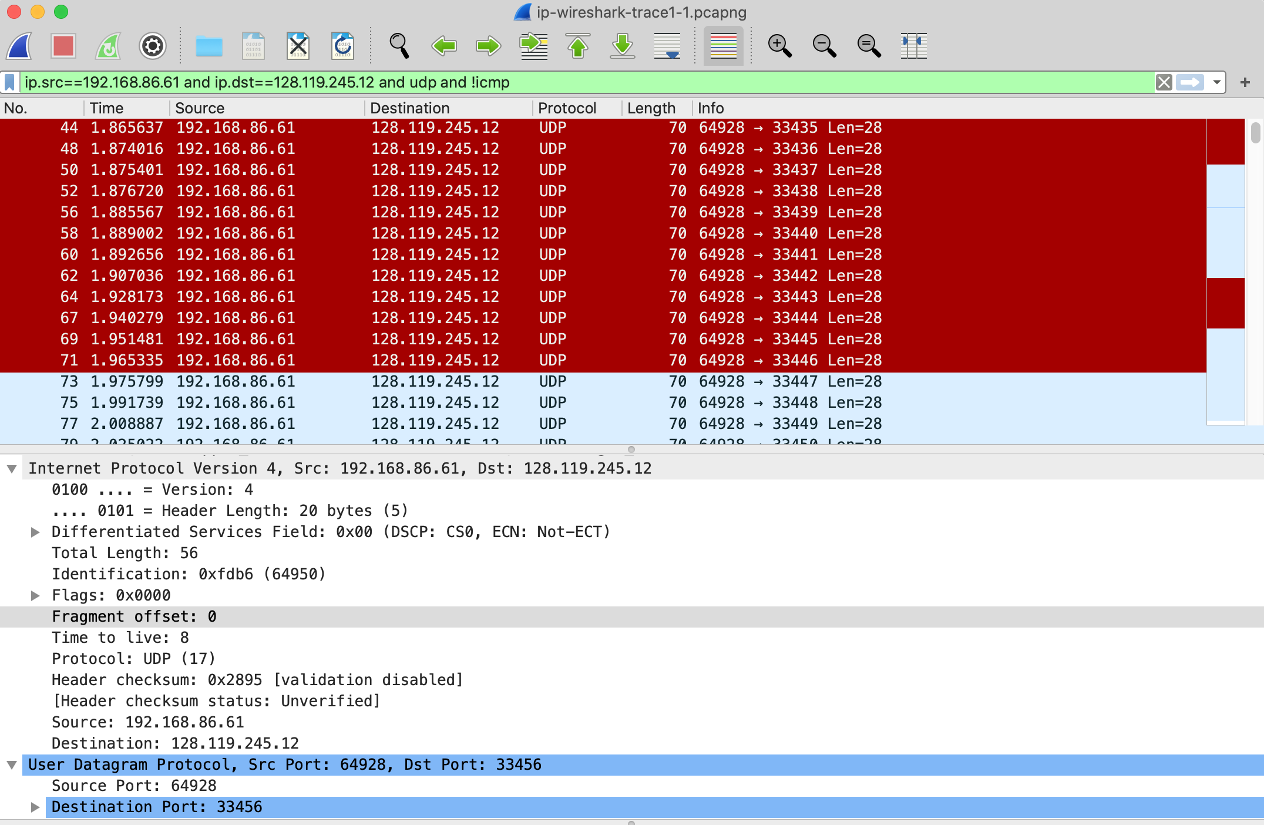
Figure 3: Wireshark screen shot, showing up segments in the tracefile ip-wireshark-trace1-1.pcapng using the display filter ip.src==192.168.86.61 and ip.dst==128.119.245.12 and udp and !icmp

- Which fields in the IP datagram always change from one datagram to the next within this series of UDP segments sent by your computer destined to 128.119.245.12, via traceroute? Why?
- Which fields in this sequence of IP datagrams (containing UDP segments) ﻿﻿﻿﻿﻿﻿﻿﻿﻿﻿﻿stay constant? Why?
- Describe the pattern you see in the values in the Identification field of the IP datagrams being sent by your computer.

Now let’s take a look at the ICMP packets being returned to your computer by the intervening routers where the TTL value was decremented to zero (and hence caused the ICMP error message to be returned to your computer). The display filter that you can use to show just these packets is “ip.dst==192.168.86.61 and icmp”.

- What is the upper layer protocol specified in the IP datagrams returned from the routers? [Note: the answers for Linux/MacOS differ from Windows here].
- Are the values in the Identification fields (across the sequence of all of ICMP packets from all of the routers) similar in behavior to your answer to question 9 above?
- Are the values of the TTL fields similar, across all of ICMP packets from all of the routers?

Part 2: Fragmentation

In this section, we’ll look at a large (3000-byte) UDP segment sent by the traceroute program that is fragmented into multiple IP datagrams. We recommend that you first consult the material on IP fragmentation from the 7th edition of our textbook (and earlier) at http://gaia.cs.umass.edu/kurose_ross/Kurose_Ross_7th_edition_section_4.3.2.pdf

Sort the packet listing from Part 1, with any display filters cleared, according to time, by clicking on the Time column.

- Find the first IP datagram containing the first part of the segment sent to 128.119.245.12 sent by your computer via the traceroute command to gaia.cs.umass.edu, after you specified that the traceroute packet length should be 3000. (Hint: This is packet 179 in the ip-wireshark-trace1-1.pcapng trace file in footnote 2. Packets 179, 180, and 181 are three IP datagrams created by fragmenting the first single 3000-byte UDP segment sent to 128.119.145.12). Has that segment been fragmented across more than one IP datagram? (Hint: the answer is yes!)
- What information in the IP header indicates that this datagram has been fragmented?
- What information in the IP header for this packet indicates whether this is the first fragment versus a latter fragment?
- Now inspect the datagram containing the second fragment of the fragmented UDP segment. What information in the IP header indicates that this is not the first datagram fragment?
- Now find the IP datagram containing the third fragment of the original UDP segment. What information in the IP header indicates that this is the last fragment of that segment?

Wireshark Lab:  NAT  Supplement to Computer Networking: A Top-Down Approach, 9th ed., J.F. Kurose and K.W. Ross  “Tell me and I forget. Show me and I remember. Involve me and I understand.” Chinese proverb  © 2005-2025, J.F Kurose and K.W. Ross, All Rights Reserved | 

Specifications for PART B: NAT
- Students are instructed to use the author’s provided pcap file to answer the questions in this lab.

In this lab, we’ll investigate the behavior of a NAT router. This lab will be different from our other Wireshark labs, where we’ve captured a trace file at a single Wireshark measurement point. Because we’re interested in capturing packets at both the input and output sides of the NAT device, we’ll need to capture packets at two locations. Also, because many students don’t have easy access to a NAT device or to two computers on which to take Wireshark measurements, this isn’t a lab that is easily done “live” by a student. So, in this lab, you’ll use Wireshark trace files that we’ve captured for you. This should be a relatively short and easy lab since the concepts behind NAT aren’t difficult, but it’ll be good nonetheless to observe NAT in action. Before beginning this lab, you’ll probably want to review the material on NAT in section 4.3.3 in the text.

NAT Measurement Scenario

In this lab, we’ll capture packets containing a simple HTTP GET request message from a client inside a home network to a remote server, and the corresponding HTTP response from that server. Within the home network, the home network router provides a NAT service, as discussed in Chapter 4. Figure 1 shows our Wireshark trace-collection scenario. We’ll capture packets in two locations, and thus this lab has two trace files:
- We’ll capture packets being received at the local area network (LAN) side of the NAT router. All devices in this LAN have addresses in 192.168.10/24. This file is named nat-inside-wireshark-trace1-1.pcapng .
- Because we’re also interested in analyzing packets being forwarded (and received) by the NAT router on its Internet-facing side, we’ll collect a second trace file on the Internet side of the router, as shown in Figure 1. Packets captured by Wireshark at this point that were sent from a host on the right to the server on the left will have undergone NAT translation by the time they reach this second measurement point. This file is named nat-outside-wireshark-trace1-1.pcapng.

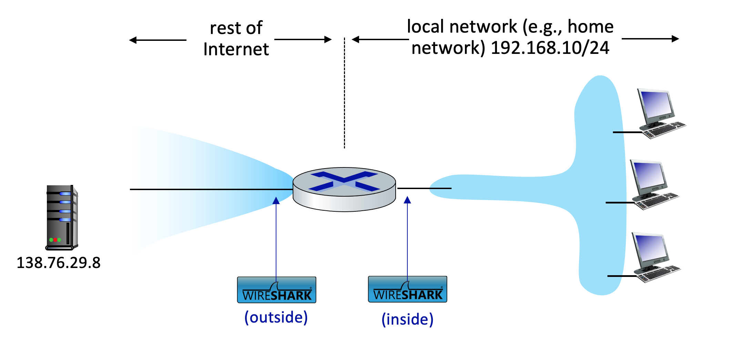
Figure 1: NAT packet capture scenario

In the scenario shown in Figure 1, one of the hosts within the LAN will send an HTTP GET request to the web server at IP address 138.76.29.8, which will respond back to the requesting host. Of course, we’re not really interested in the HTTP GET request itself, but rather how the NAT router changes the IP addresses and port numbers of the datagram containing the GET request on the LAN side (inside) to addresses and port numbers in the fowarded outgoing datagram on the Internet side (outside) of the NAT router.

Let’s first take a look at what’s happening on the LAN side of the NAT router. Open the nat-inside-wireshark-trace1-1.pcapng trace file. In this file, you should see an HTTP GET request addressed to the external web server at IP address 138.76.29.8, as well as the subsequent HTTP response message (“200 OK”). Both of these messages in the trace file were captured on the LAN side of the router.

Answer the following questions.

- What is the IP address of the client that sends the HTTP GET request in the nat-inside-wireshark-trace1-1.pcapng trace? What is the source port number of the TCP segment in this datagram containing the HTTP GET request? What is the destination IP address of this HTTP GET request? What is the destination port number of the TCP segment in this datagram containing the HTTP GET request?
- At what time is the corresponding HTTP 200 OK message from the webserver forwarded by the NAT router to the client on the router’s LAN side?
- What are the source and destination IP addresses and TCP source and destination ports on the IP datagram carrying this HTTP 200 OK message?

In the following we’ll focus on these two HTTP messages (GET and 200 OK). Our goal below will be to locate these two HTTP messages in the trace file nat-outside-wireshark-trace1-1.pcapng, captured on the Internet-side link between the router and the ISP. Because the captured packets heading towards the server will have already been forwarded through the NAT router, some of the IP address and port numbers will have been changed as a result of NAT translation.

Open the trace file nat-outside-wireshark-trace1-1.pcapng. Note that the time stamps in this file and the nat-inside-wireshark-trace1-1.pcapng file are not necessarily synchronized.

In the nat-outside-wireshark-trace1-1.pcapng trace file, find the HTTP GET message that corresponds to the HTTP GET message that was sent from the client to the 138.76.29.8 server at time t=0.27362245, where t=0.27362245 is the time at which this message was sent, as recorded in the nat-inside-wireshark-trace1-1.pcapng trace file.
- At what time does this HTTP GET message appear in the nat-outside-wireshark-trace1-1.pcapng trace file?
- What are the source and destination IP addresses and TCP source and destination port numbers on the IP datagram carrying this HTTP GET (as recorded in the nat-outside-wireshark-trace1-1.pcapng trace file)?
- Which of these four fields are different than in your answer to question 1 above?
- Which of the following fields in the IP datagram carrying the HTTP GET are changed from the datagram received on the local area network (inside) to the corresponding datagram forwarded on the Internet side (outside) of the NAT router: Version, Header Length, Flags, Checksum?

Let’s continue to look at the nat-outside-wireshark-trace1-1.pcapng trace file. Find the HTTP reply containing the “200 OK” message that was received in response to the HTTP GET request you just examined in questions 4-7 above.
- At what time does this message appear in the nat-outside-wireshark-trace1-1.pcapng trace file?
- What are the source and destination IP addresses and TCP source and destination port numbers on the IP datagram carrying this HTTP reply (“200 OK”) message (as recorded in the nat-outside-wireshark-trace1-1.pcapng trace file)?

Lastly, let’s consider what happens when the NAT router receives this datagram that you examined in questions 9 and 10, performs NAT translation, and finally forwards that datagram to the destination host on the LAN side. Based on your answers to questions 1 through 10 above and your knowledge of how NAT works, you should be able to answer the following question without actually looking at the nat-inside-wireshark-trace1-1.pcapng trace file:
- What are the source and destination IP addresses and TCP source and destination port numbers on the IP datagram carrying the HTTP reply (“200 OK”) that is forwarded from the router to the destination host in the right of Figure 1?

Wireshark Lab:  DHCP  Supplement to Computer Networking: A Top-Down Approach, 9th ed., J.F. Kurose and K.W. Ross  “Tell me and I forget. Show me and I remember. Involve me and I understand.” Chinese proverb  © 2005-2025, J.F Kurose and K.W. Ross, All Rights Reserved | 

Specifications for PART C: DHCP
- Students are required to capture their own trace files and use them to answer the questions in this lab.

In this lab, we’ll take a quick look at the Dynamic Host Configuration Protocol, DHCP. Recall that DHCP is used extensively in corporate, university and home-network wired and wireless LANs to dynamically assign IP addresses to hosts, as well as to configure other network configuration information.

Before getting started, you’ll probably want to review the coverage of DHCP in Section 4.4.3 in the text. In particular, you’ll want to pay close attention to Figure 4.24, since we’ll be studying the DHCP Discover, Offer, Request and ACK messages shown in Figure 4.24.

Gathering a Packet Trace

The first two steps in the DHCP protocol in Figure 4.24 (using the Discover and Offer messages) are optional (in the sense that they need not always be used when, for example, a new IP address is needed, or an existing DHCP address is to be renewed); the Request and ACK messages are not. In order to collect a trace that will contain all four DHCP message types, we’ll need to take a few command line actions on a Mac, Linux or PC.

On a Mac:
- In a terminal window/shell enter the following command:
% sudo ipconfig set en0 none
Where en0 (in this example) is the interface on which you want to capture packets using Wireshark. You can easily find the list of interface names in Wireshark by choosing Capture->options. This command will de-configure network interface en0.
- Start up Wireshark, capturing packets on the interface you de-configured in Step 1.
- In the terminal window/shell enter the following command:
% sudo ipconfig set en0 dhcp
This will cause the DHCP protocol to request and receive an IP address and other information from the DHCP server.
- After waiting for a few seconds, stop Wireshark capture.

On a Linux machine:
- In a terminal window/shell, enter the following commands:
sudo ip addr flush en0
sudo dhclient -r
where en0 (in this example) is the interface on which you want to capture packets using Wireshark. You can easily find the list of interface names in Wireshark by choosing Capture -> Options. This command will remove the existing IP address of the interface, and release any existing DHCP address leases.
- Start up Wireshark, capturing packets in the interface you de-configured in Step 1.
- In the terminal window/shell, enter the following command:
sudo dhclient en0
where, as with above, en0 is the interface on which you are currently capturing packets. This will cause the DHCP protocol to request and receive an IP address and other information from the DHCP server.
- After waiting for a few seconds, stop Wireshark capture.

On a PC:
- In a command-line window enter the following command:
> ipconfig /release
This command will cause your PC to give up its IP address.
- Start up Wireshark.
- In the command-line window enter the following command:
> ipconfig /renew
This will cause the DHCP protocol to request and receive an IP address and other information from a DHCP server.
- After waiting for a few seconds, stop Wireshark capture.

After stopping Wireshark capture in step 4, you should take a peek in your Wireshark window to make sure you’ve actually captured the packets that we’re looking for. If you enter “dhcp” into the display filter field (as shown in the light green field in the top left of Figure 1), your screen (on a Mac) should look similar to Figure 1.

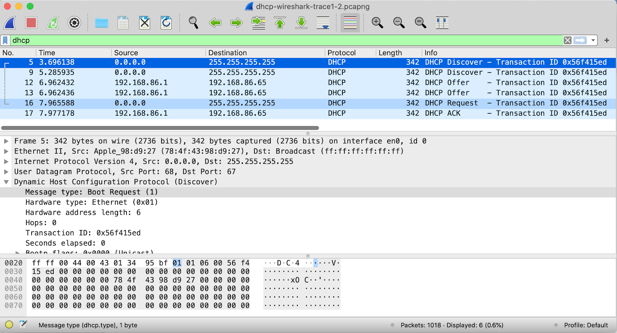
Figure 1: Wireshark display, showing the capture of DHCP Discover, Offer, Request and ACK messages

DHCP Questions

Let’s start by looking at the DHCP Discover message. Locate the IP datagram containing the first Discover message in your trace.

- Is this DHCP Discover message sent out using UDP or TCP as the underlying transport protocol?
- What is the source IP address used in the IP datagram containing the Discover message? Is there anything special about this address? Explain.
- What is the destination IP address used in the datagram containing the Discover message. Is there anything special about this address? Explain.
- What is the value in the transaction ID field of this DHCP Discover message?
- Now inspect the options field in the DHCP Discover message. What are five pieces of information (beyond an IP address) that the client is suggesting or requesting to receive from the DHCP server as part of this DHCP transaction?

Now let’s look at the DHCP Offer message. Locate the IP datagram containing the DHCP Offer message in your trace that was sent by a DHCP server in the response to the DHCP Discover message that you studied in questions 1-5 above.

- How do you know that this Offer message is being sent in response to the DHCP Discover message you studied in questions 1-5 above?
- What is the source IP address used in the IP datagram containing the Offer message? Is there anything special about this address? Explain.
- What is the destination IP address used in the datagram containing the Offer message? Is there anything special about this address? Explain. [Hint: Look at your trace carefully. The answer to this question may differ from what you see in Figure 4.24 in the textbook. If you really want to dig into this, consult the DHCP RFC: https://www.ietf.org/rfc/rfc2131.txt, page 24.﻿﻿﻿﻿﻿﻿﻿﻿﻿﻿﻿﻿﻿﻿﻿﻿﻿﻿﻿﻿]
- Now inspect the options field in the DHCP Offer message. What are five pieces of information that the DHCP server is providing to the DHCP client in the DHCP Offer message?

It would appear that once the DHCP Offer message is received, that the client may have all of the information it needs to proceed. However, the client may have received OFFERs from multiple DHCP servers and so a second phase is needed, with two more mandatory messages – the client-to-server DHCP Request message, and the server-to-client DHCP ACK message is needed. But at least the client knows there is at least one DHCP server out there! Let’s take a look at the DHCP Request message, remembering that although we’ve already seen a Discover message in our trace, that is not always the case when a DHCP request message is sent.

Locate the IP datagram containing the first DHCP Request message in your trace, and answer the following questions.
- What is the UDP source port number in the IP datagram containing the first DHCP Request message in your trace? What is the UDP destination port number being used?
- What is the source IP address in the IP datagram containing this Request message? Is there anything special about this address? Explain.
- What is the destination IP address used in the datagram containing this Request message. Is there anything special about this address? Explain.
- What is the value in the transaction ID field of this DHCP Request message? Does it match the transaction IDs of the earlier Discover and Offer messages?

Locate the IP datagram containing the first DHCP ACK message in your trace, and answer the following questions.
- What is the source IP address in the IP datagram containing this ACK message? Is there anything special about this address? Explain.
- What is the destination IP address used in the datagram containing this ACK message. Is there anything special about this address? Explain.
- What is the name of the field in the DHCP ACK message (as indicated in the Wireshark window) that contains the assigned client IP address?
- For how long a time (the so-called “lease time”) has the DHPC server assigned this IP address to the client?
- What is the IP address (returned by the DHCP server to the DHCP client in this DHCP ACK message) of the first-hop router on the default path from the client to the rest of the Internet?

References to figures and sections are for the 8th edition of our text, Computer Networks, A Top-down Approach, 8^{h} ed., J.F. Kurose and K.W. Ross, Addison-Wesley/Pearson, 2020. Our website for this book is http://gaia.cs.umass.edu/kurose_ross You’ll find lots of interesting open material there.
You can download the zip file http://gaia.cs.umass.edu/wireshark-labs/wireshark-traces-9e.zip and extract the trace file nat-inside-wireshark-trace1-1.pcapng. These trace files can be used to answer these Wireshark lab questions without actually capturing packets on your own. Each trace was made using Wireshark running on one of the author’s computers, while performing the steps indicated in the Wireshark lab. Once you’ve downloaded a trace file, you can load it into Wireshark and view the trace using the File pull down menu, choosing Open, and then selecting the trace file name.
For the author’s class, when answering the following questions with hand-in assignments, students sometimes need to print out specific packets (see the introductory Wireshark lab for an explanation of how to do this) and indicate where in the packet they’ve found the information that answers a question. They do this by marking paper copies with a pen or annotating electronic copies with text in a colored font. There are also learning management system (LMS) modules for teachers that allow students to answer these questions online and have answers auto-graded for these Wireshark labs at http://gaia.cs.umass.edu/kurose_ross/lms.htm
Specify time using the time since the beginning of the trace (rather than absolute, wall-clock time).
References to figures and sections are for the 8th edition of our text, Computer Networks, A Top-down Approach, 9^{h} ed., J.F. Kurose and K.W. Ross, Addison-Wesley/Pearson, 2025. Our website for this book is http://gaia.cs.umass.edu/kurose_ross You’ll find lots of interesting open material there.
References to figures and sections are for the 9th edition of our text, Computer Networks, A Top-down Approach, 9^{h} ed., J.F. Kurose and K.W. Ross, Addison-Wesley/Pearson, 2025. Our website for this book is http://gaia.cs.umass.edu/kurose_ross You’ll find lots of interesting open material there.
You can download the zip file http://gaia.cs.umass.edu/wireshark-labs/wireshark-traces-9e.zip and extract the trace file ip-wireshark-trace1-1.pcapng. This trace file can be used to answer these Wireshark lab questions without actually capturing packets on your own. The trace was made using Wireshark running on one of the author’s computers, while performing the steps in this Wireshark lab. Once you’ve downloaded a trace file, you can load it into Wireshark and view the trace using the File pull down menu, choosing Open, and then selecting the trace file name.
For the author’s class, when answering the following questions with hand-in assignments, students sometimes need to print out specific packets (see the introductory Wireshark lab for an explanation of how to do this) and indicate where in the packet they’ve found the information that answers a question. They do this by marking paper copies with a pen or annotating electronic copies with text in a colored font. There are also learning management system (LMS) modules for teachers that allow students to answer these questions online and have answers auto-graded for these Wireshark labs at http://gaia.cs.umass.edu/kurose_ross/lms.htm
Note: if you find your packet has not been fragmented, you should download the zip file in footnote 2 and extract the trace file ip-wireshark-trace1-1.pcapng . If your computer has an Ethernet or WiFi interface, a packet size of 3000 should cause fragmentation.

